Lab task 6.1

Exercise 1:

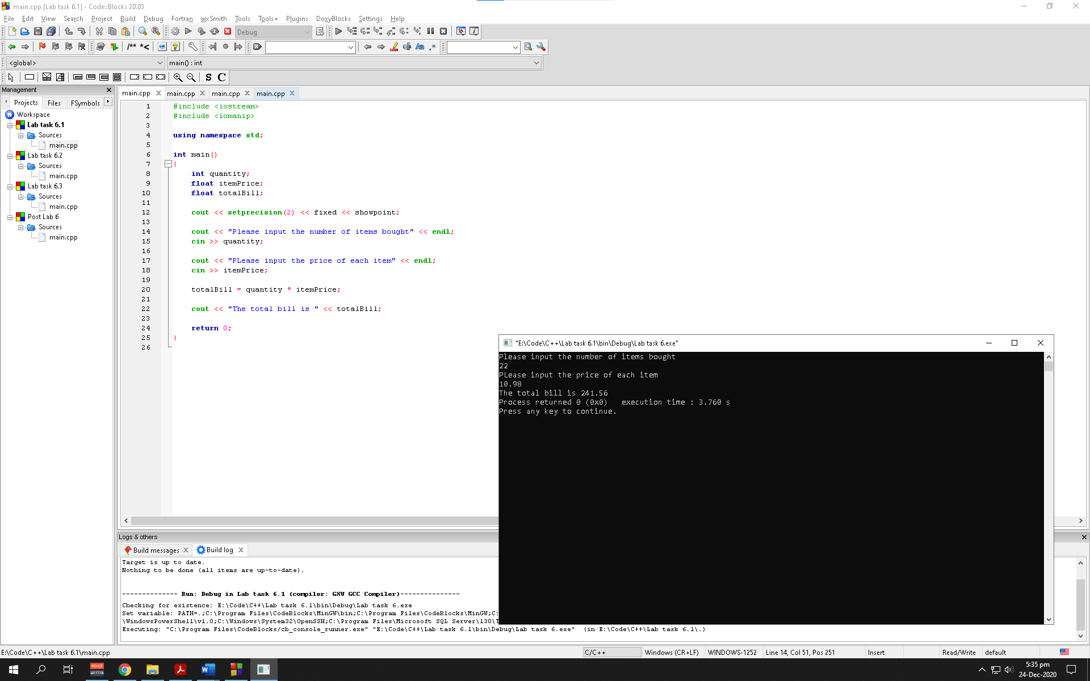

Observation: The program asks the user to input number of items he/she have bought and at what price. The program then calculates the total price and prompts the user with the value with a fixed setprecision of 2

Exercise 2:

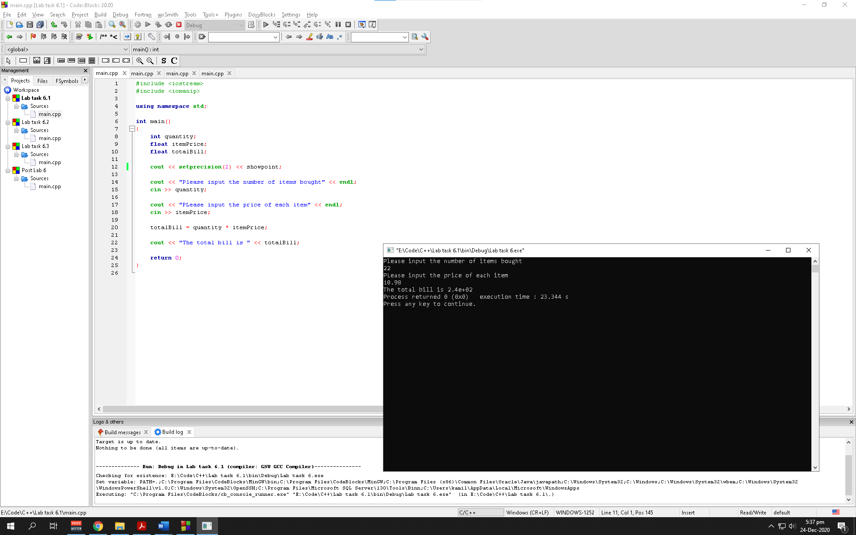

Fixed attribute forces cout to print digits in a decimal format instead to scientific notation

Observation: The program asks the user to input number of items he/she have bought and at what price. The program then calculates the total price and prompts the user with the value with a setprecision of 2

Exercise 3:

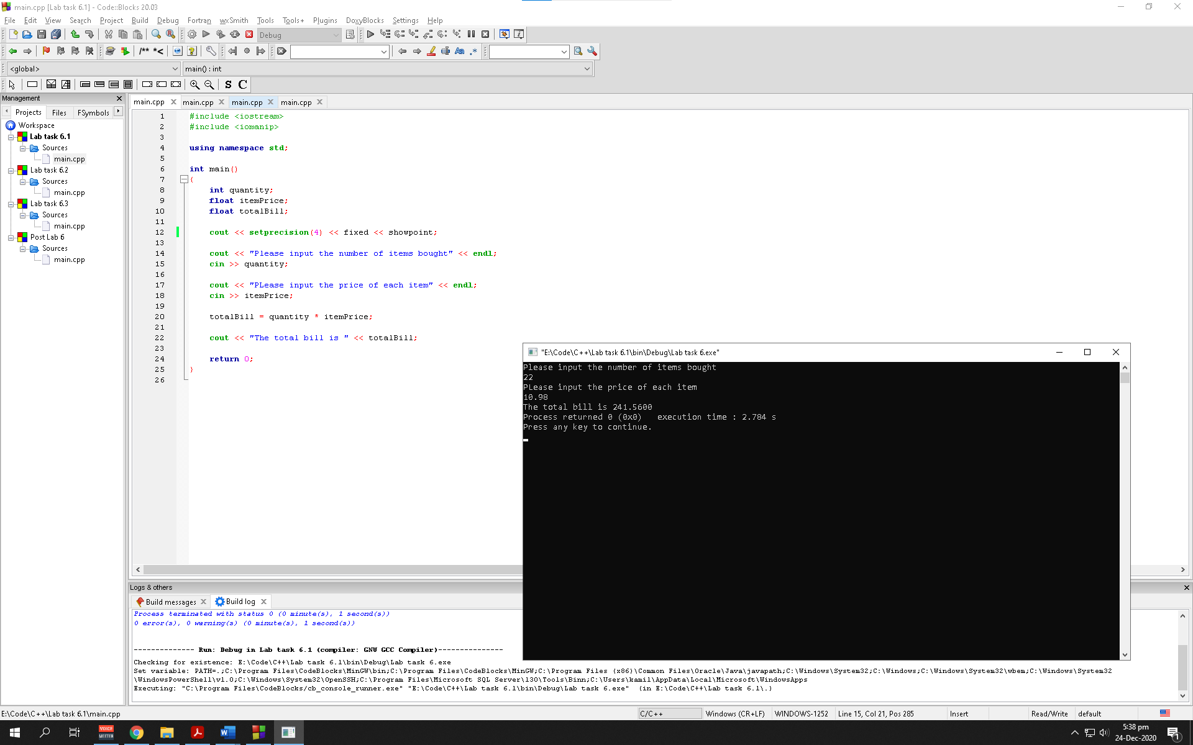

setprecision manipulator is used to control the number of significant figures. Alongside fixed attribute, setprecision manipulator specifies number of digits to the right of the decimal point

Observation: The program asks the user to input number of items he/she have bought and at what price. The program then calculates the total price and prompts the user with the value with a fixed setprecision of 4

Lab task 6.2

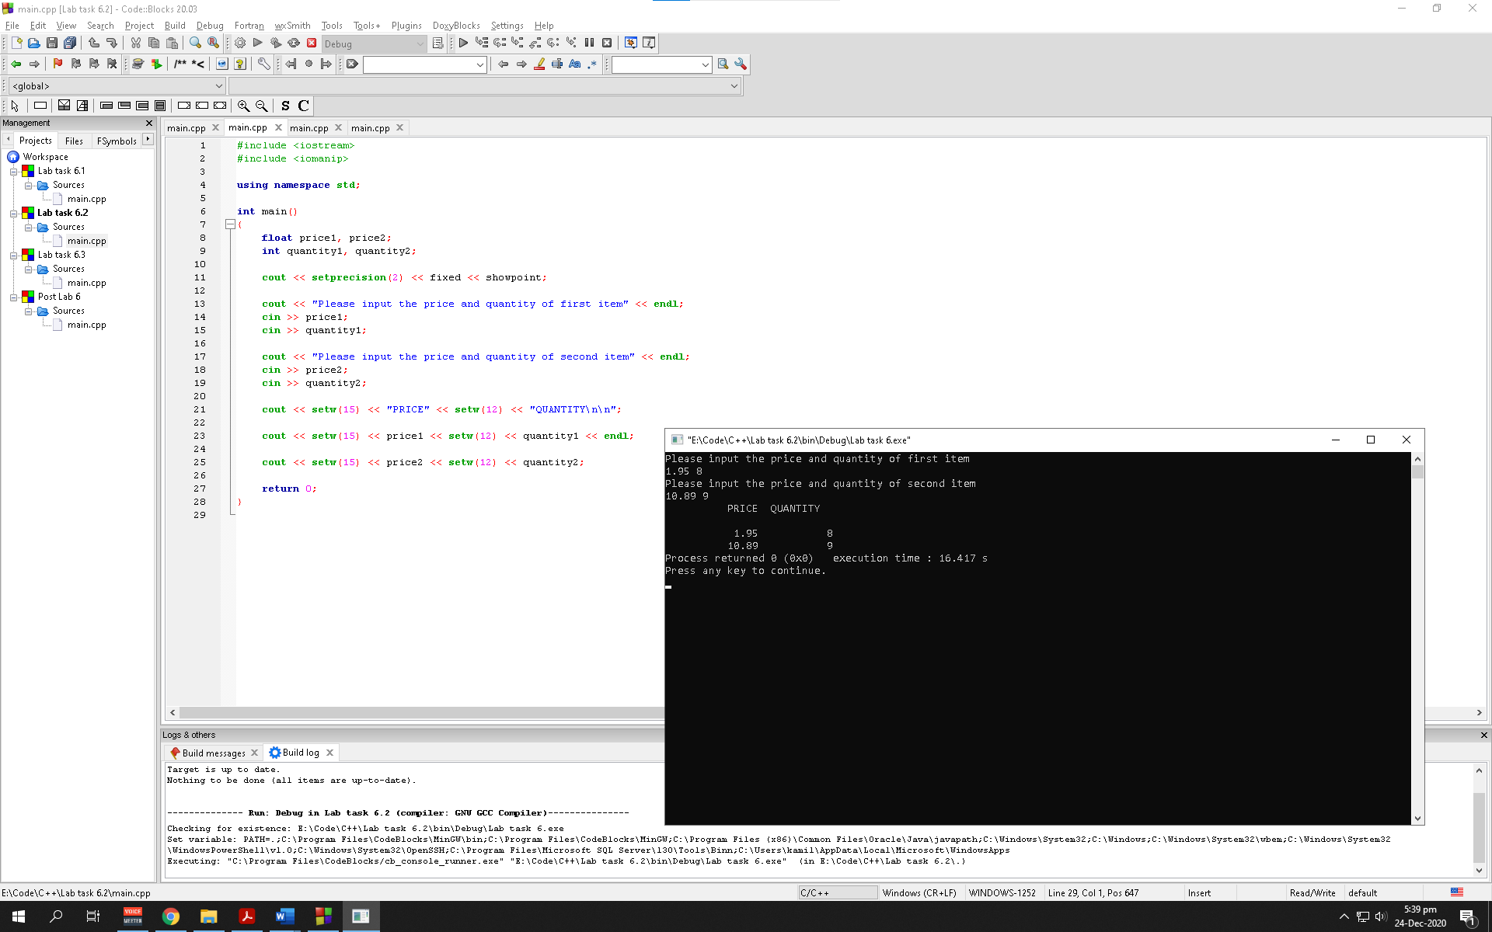

Observation: The program asks the user to input 2 items with their prices and visualizes the user with those values in a tabular form using setw manipulators. The program also displays prices with fixed setprecision of 2 since they are initialized with floating variables

Lab task 6.3

Exercise 1:

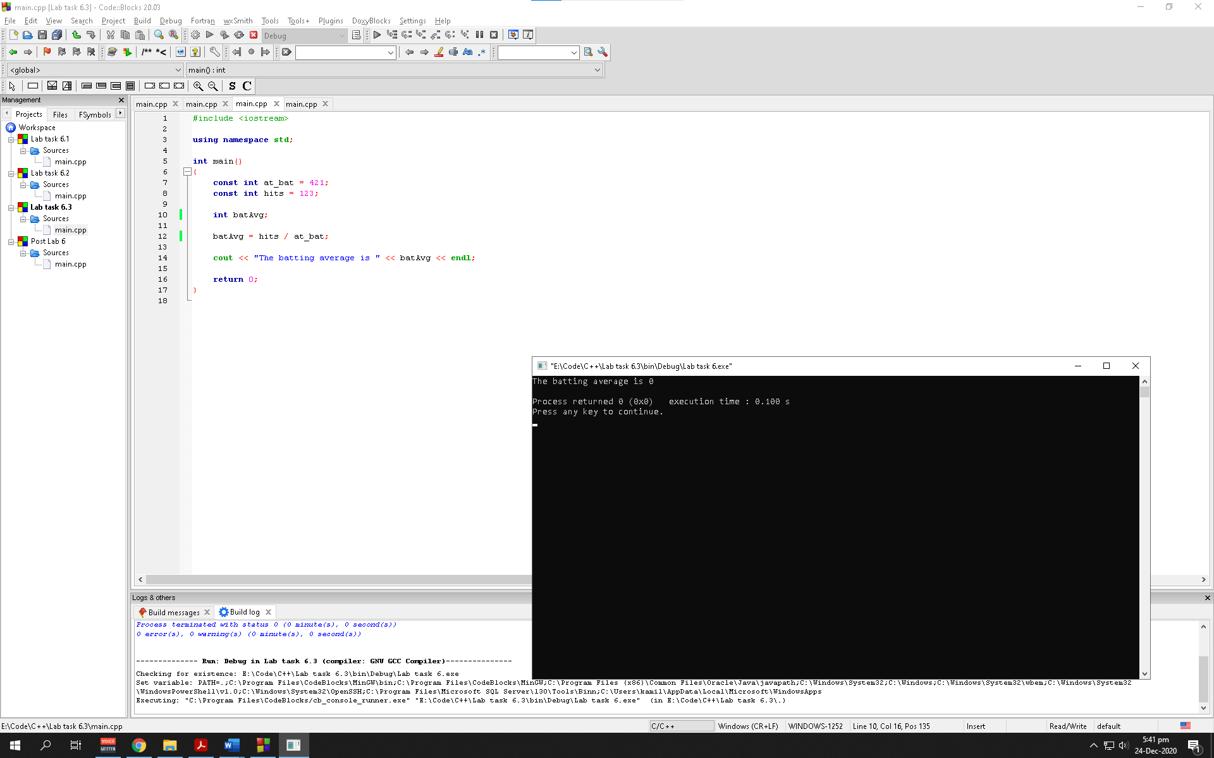

The batting average is 0

Observation: The program calculates the batAvg variable using the constants defined and outputs it to the user. Since the value of batAvg is a decimal value and the batAvg is initialized at integer, the value displayed is 0

Exercise 2:

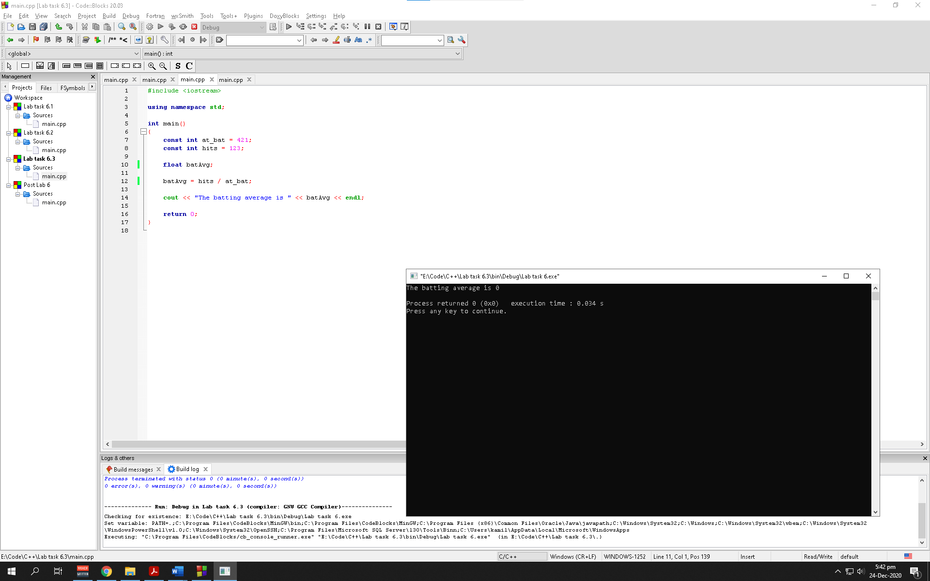

The batting average is 0

Observation: The program calculates the batAvg variable using the constants defined and outputs it to the user. Since, the constants being divided are both integers so the program stores an integer value in batAvg (a floating variable) which is later displayed as 0 to the user

Exercise 3:

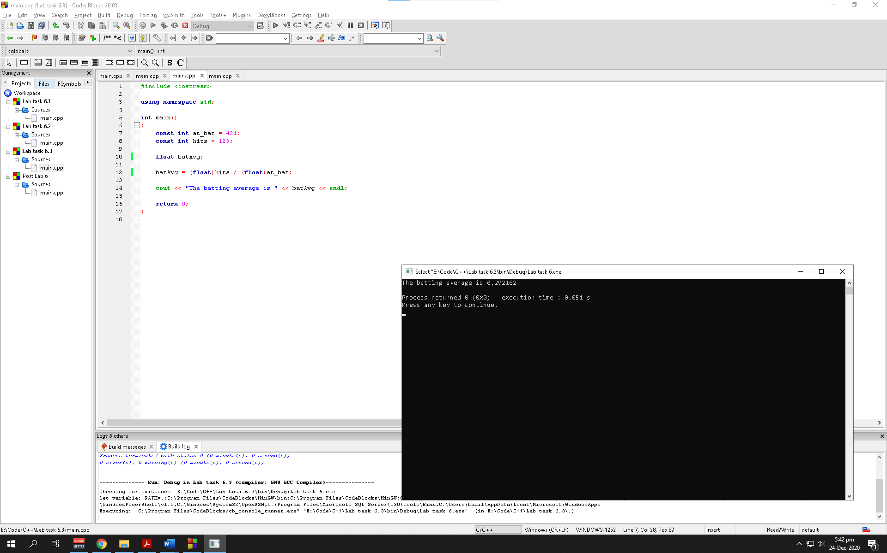

The batting average is 0.292162

Observation: The program calculates the batAvg variable using the constants defined and outputs it to the user. The constants being divided are both integers so the program stores an integer value in batAvg (a floating variable). To resolve this program the constants are typecast-ed as a floating variable which lets the program store a float value in batAvg which is later displayed to the user

Post lab task

Task 1:

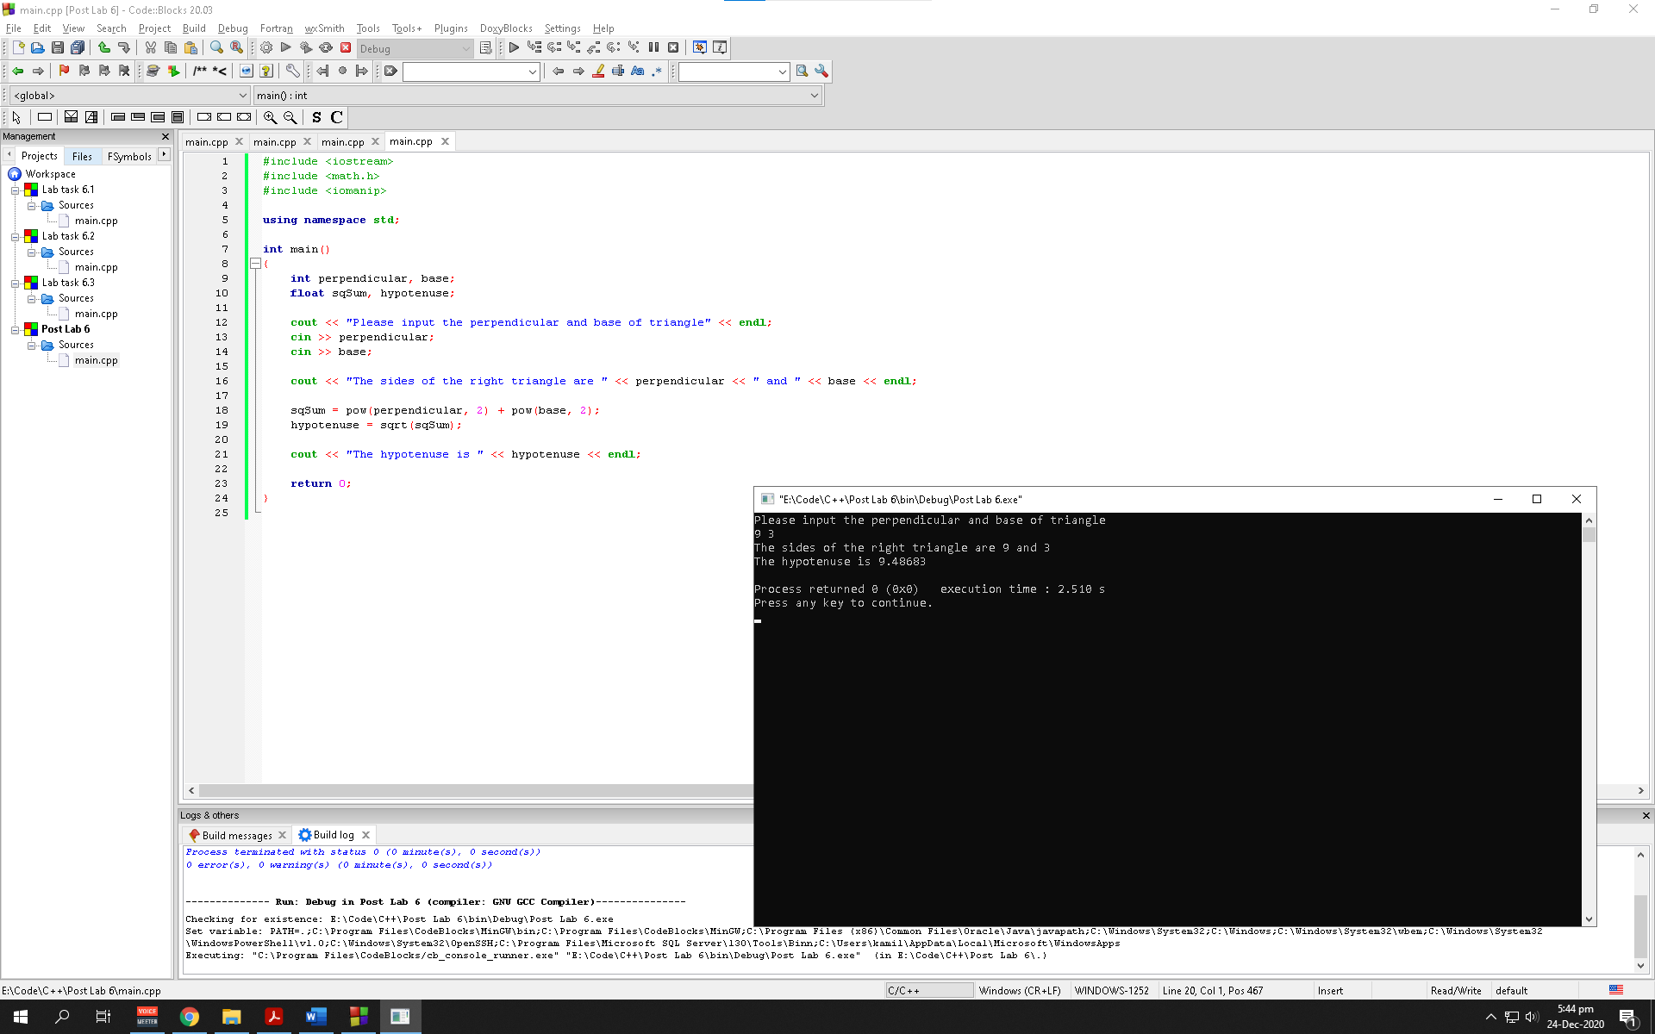

Observation: The program asks the user the value of perpendicular and base side of a right-angle triangle to calculate its hypotenuse. This is done by using the pow and sqrt attribute to make the program simpler. The value is then displayed to the user

Task 2:

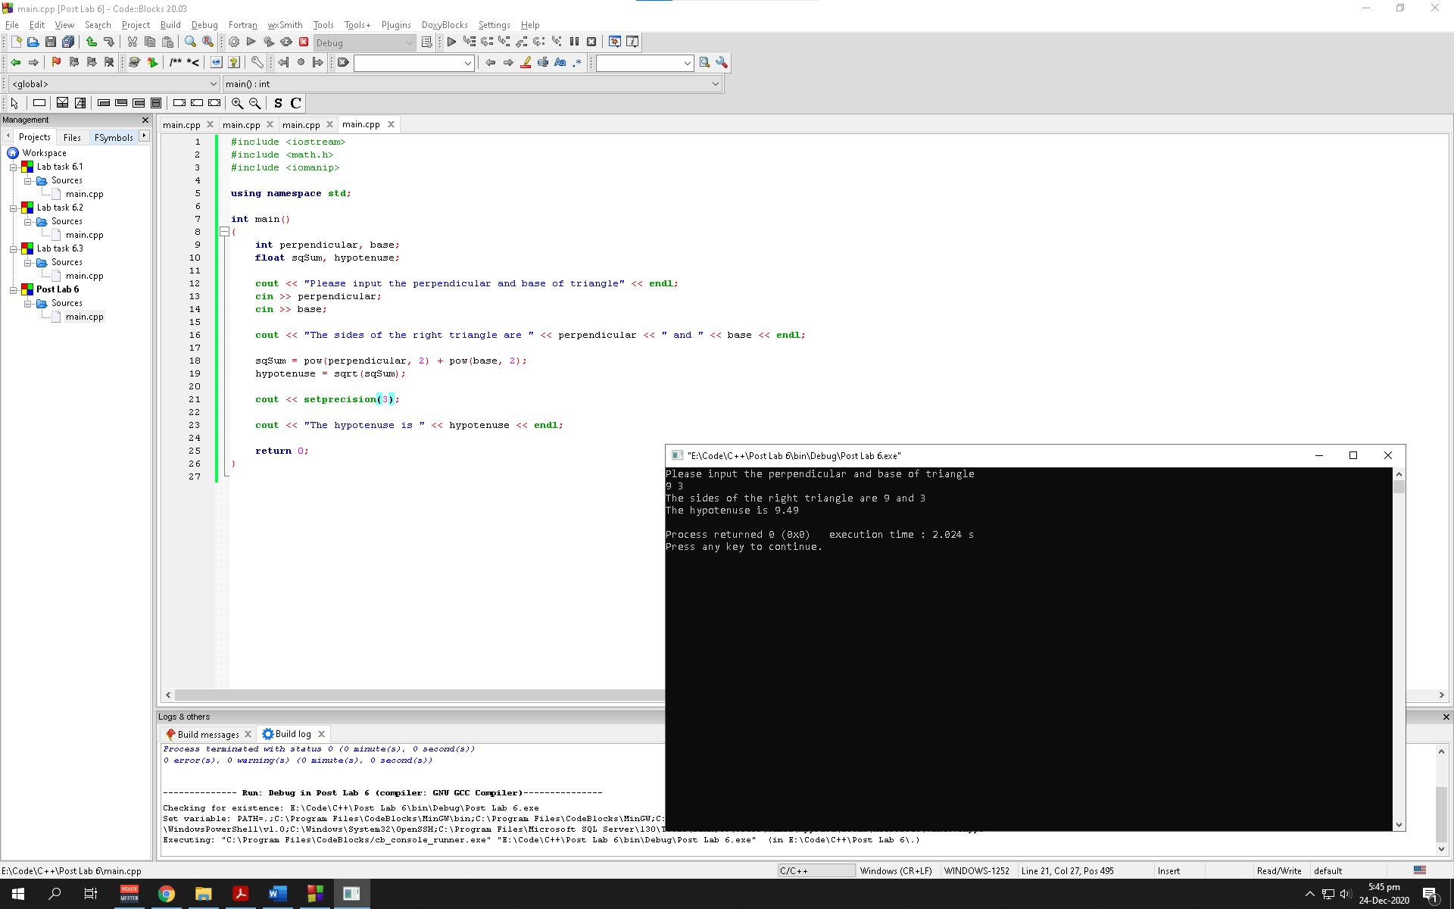

Observation: The program asks the user the value of perpendicular and base side of a right-angle triangle to calculate its hypotenuse. This is done by using the pow and sqrt attribute to make the program simpler. The value is then displayed to the user with a setprecision of 3